

**HONEY PRICE PREDICTION BASED**

**ON PURITY**

**1.Introduction**

**1.1Project Overview**

Honey, a natural sweetener, is prized for its unique flavor, aroma, and nutritional benefits. The quality and purity of honey significantly impact its market value, making it essential to develop a reliable system for predicting honey prices based on its purity. This overview explores the key factors influencing honey prices, the importance of honey purity, and the various methods for predicting honey prices, highlighting the significance of accurate price prediction in the honey industry.

Honey purity is typically classified into different grades, including:

1. **High-quality honey**: With a high pollen count and low moisture content, this grade commands a premium price.
2. **Standard honey:** Meeting basic quality standards, this grade is widely available

and moderately priced.

1. **Low-quality honey:** With high moisture content and low pollen count, this grade is often discounted.

**1.2 Project Objective**

The primary objective of this project is to develop a comprehensive machine learning model that accurately predicts honey prices based on purity metrics. This model aims to assist beekeepers, honey producers, and market analysts in optimizing resource allocation and maximizing profitability by understanding and anticipating market dynamics influenced by honey purity.

**2. Project Initialization and Planning Phase**

The "Project Initialization and Planning Phase" marks the project's outset, defining goals, scope, and stakeholders. This crucial phase establishes project parameters, identifies key team members, allocates resources, and outlines a realistic timeline. It also involves risk assessment and mitigation planning. Successful initiation sets the foundation for a well-organized and efficiently executed machine learning project, ensuring clarity, alignment, and proactive measures for potential challenges.

**Activity 1: Define Problem Statement**

A honey producer aims to accurately predict the market price of honey based on its purity. The challenge lies in understanding and effectively utilizing purity metrics such as moisture content, pollen count, and sugar content, which significantly impact honey prices. Despite the producer's efforts to maintain high purity standards, uncertainty persists regarding the accurate estimation of these factors' influence on market prices.

**Ref. template:**

**Honey price prediction Problem Statement Report:**[**click Here**](https://drive.google.com/file/d/1qUNlLk3irMXCB3_rpsLN2MrqAQLOwEni/view?usp=sharing)

**Activity 2: Project Proposal (Proposed Solution)**

Our innovative proposed solution harnesses advanced machine learning algorithms and

robust data analytics to predict honey prices based on purity, aiming to foster fair market

practices, enhance consumer safety, and stimulate industry growth. By leveraging

predictive models, we empower beekeepers, honey producers, and consumers with

reliable insights into pricing dynamics influenced by honey industry.

**Ref. template:**

**Honey price prediction Project Proposal Report:** [**Click Here**](https://drive.google.com/file/d/12RQTEJTuf5C2Nd42o_p_l5HETWWEY-_x/view?usp=sharing)

**Activity 3: Initial Project Planning**

Initial Project Planning involves outlining key objectives, defining scope, and identifying the price prediction. It encompasses setting timelines, allocating resources, and determining the overall project strategy. During this phase, the team establishes a clear understanding of the dataset, formulates goals for analysis, and plans the workflow for data processing. Effective initial planning lays the foundation for a systematic and well-executed project, ensuring successful outcomes.

**Ref. template:**

**Honey price prediction Initial Project Planning Report:** [**Click Here**](https://drive.google.com/file/d/11yM4d80CkTMQbCLL8et9qCqwXamoQXgf/view?usp=sharing)

**3. Data Collection and Preprocessing Phase**

The Data Collection and Preprocessing Phase involves executing a plan to gather relevant

Honey price prediction data from Kaggle, ensuring data quality through verification and addressing missing values. Preprocessing tasks include cleaning, encoding, and organizing the dataset for subsequent exploratory analysis and machine learning model development.

**Activity 1: Data Collection Plan, Raw Data Sources Identified**

The dataset for "Honey price Prediction" is sourced from Kaggle, a reputable platform

known for its diverse collection of datasets in agricultural sciences and predictive analytics.

This dataset is meticulously curated to encompass a wide array of variables essential for

accurate blueberry yield prediction. These variables include climatic factors,Pollinating factors,

and historical yield data. This comprehensive dataset provides a robust foundation for

developing predictive models.

**Ref. template:**

**Honey price prediction Raw Data Sources Report:** [Click Here](https://drive.google.com/file/d/1HhDD5a07E9rtKqZKzqkh-jUv_1j1qYNH/view?usp=sharing)

**Activity 2: Data Quality Report**

The dataset for " Honey price Prediction" is sourced from Kaggle. It includes climatic

factors,Pollinating factors and historical yield data. . Data quality is ensured through

verification, addressing missing values and handing Outliers, establishing a reliable foundation

for predictive modeling.

**Ref. template:**

**Honey price prediction Data Quality Report:** [Click Here](https://drive.google.com/file/d/1nNO8v8zzvB9FsSGyxMxt_XZbRE7_X7ar/view?usp=sharing)

**Activity 3: Data Exploration and Preprocessing**

Data Exploration involves analyzing the Honey price prediction dataset to understand patterns, distributions, and outliers. Preprocessing includes handling missing values, scaling, and encoding categorical variables. These crucial steps enhance data quality, ensuring the reliability and effectiveness of subsequent analyses in the Honey price prediction project.

**Ref. template:**

**Honey price prediction Data Exploration and Preprocessing Report:** [**Click Here**](https://drive.google.com/file/d/1544v3lNJ1vY_OX4zyLBjGKKwMhhJsgFk/view?usp=sharing)

**4. Model Development Phase**

The Model Development Phase entails crafting a predictive model for loan approval. It

encompasses strategic feature selection, evaluating and selecting models (Linear

Regession,Random Forest, Decision Tree), initiating training with code, and rigorously

validating and assessing model performance for informed decision-making in the lending

process.

**Activity 1: Feature Selection Report**

The Feature Selection Report outlines the rationale behind choosing specific features for the honey price prediction model. It evaluates relevance, importance, and impact on predictive accuracy, ensuring the inclusion of key factors influencing the model's ability to predict honey prices accurately.

**Ref. template: Honey price prediction Feature Selection Report:** [**Click Here**](https://drive.google.com/file/d/1zUJ98pBiAEUewsGu3ZX-qdKfjF6s40yl/view?usp=sharing)

 **Activity 2: Model Selection Report**

The Model Selection Report details the rationale behind choosing Linear Regression, Random Forest, Decision Tree, models for Honey price prediction. It considers each model's strengths in handling complex relationships, interpretability, adaptability, and overall predictive performance, ensuring an informed choice aligned with project objectives.

**Ref. template:**

**Honey price prediction Model Selection Report:** [**Click Here**](https://drive.google.com/file/d/1gd38PRIj4Y7J5Mlj35MGAu39XuiafuP4/view?usp=sharing)

**Activity 3: Initial Model Training Code, Model Validation and Evaluation Report**

The Initial Model Training Code employs selected algorithms on the Honey price prediction dataset, setting the foundation for predictive modeling. The subsequent Model Validation and Evaluation Report rigorously assesses model performance, employing metrics likeMAE,MSE,R-Squared and accuracy to ensure reliability and effectiveness in predicting loan outcomes.

**Ref. template:**

**Honey price prediction Model Development Phase Template:** [**Click Here**](https://drive.google.com/file/d/17yb_iNScbTKYCZBngqbFnPzJm81C--LV/view?usp=sharing)

**5. Model Optimization and Tuning Phase**

The Model Optimization and Tuning Phase involves refining machine learning models for peak

performance. It includes optimized model code, fine-tuning hyperparameters, comparing

performance metrics, and justifying the final model selection for enhanced predictive accuracy

and efficiency.

**Activity 1: Hyperparameter Tuning Documentation**

The Random forest model was selected for its superior performance, exhibiting high accuracy during hyperparameter tuning. Its ability to handle complex relationships, minimize overfitting, and optimize predictive accuracy aligns with project objectives, justifying its selection as the final model.

**Activity 2: Performance Metrics Comparison Report**

The Performance Metrics Comparison Report contrasts the baseline and optimized metrics for various models, specifically highlighting the enhanced performance of the Random forest model. This assessment provides a clear understanding of the refined predictive capabilities achieved through hyperparameter tuning.

**Activity 3: Final Model Selection Justification**

The Final Model Selection Justification articulates the rationale for choosing Random forest as the ultimate model. Its exceptional accuracy, ability to handle complexity, and successful hyperparameter tuning align with project objectives, ensuring optimal Honey price predictions.

**Ref. template:**

**Honey price prediction Optimization and Tuning Phase Report:**[**Click Here**](https://drive.google.com/file/d/1HGA7LY6vFOPVY21dvxG9WqcQZamQg1Ot/view?usp=sharing)

**6.Results**

**Index Page**

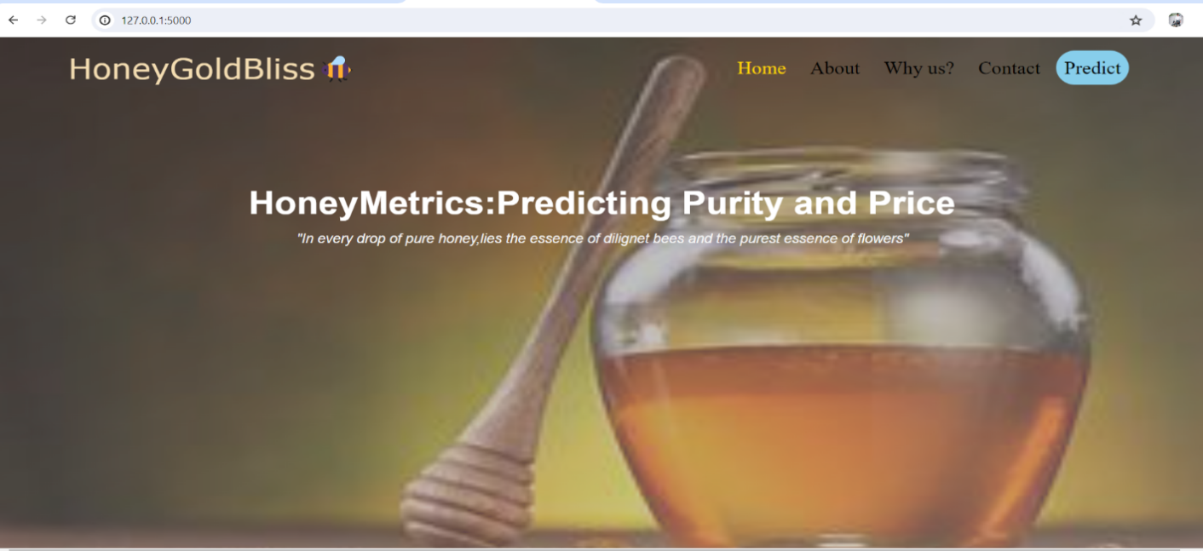

**About page**

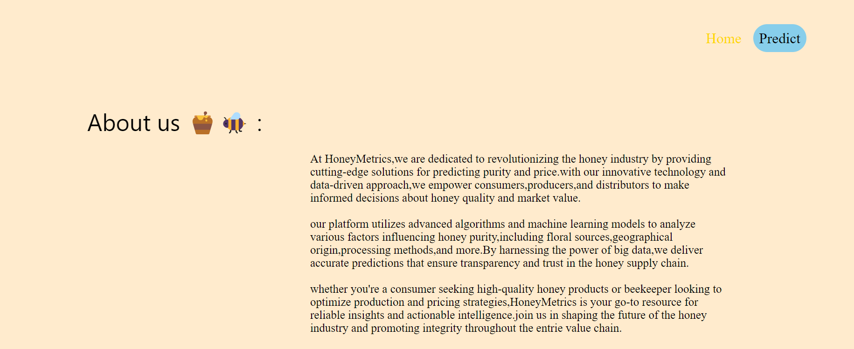

**Details page**

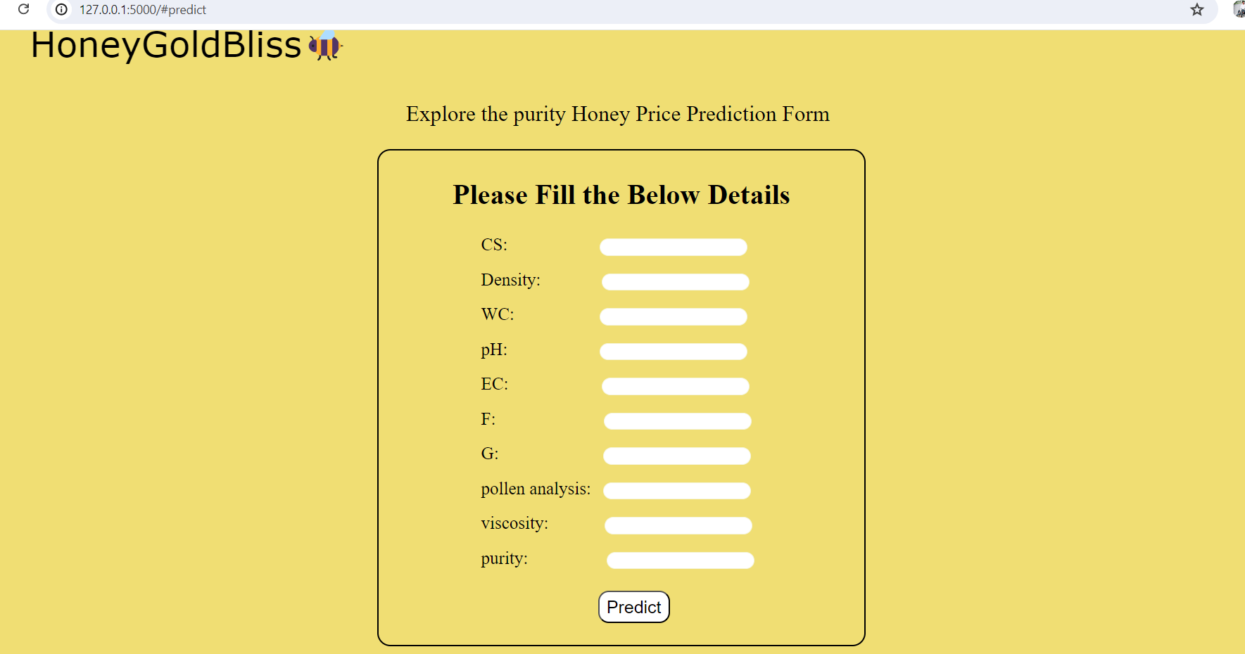

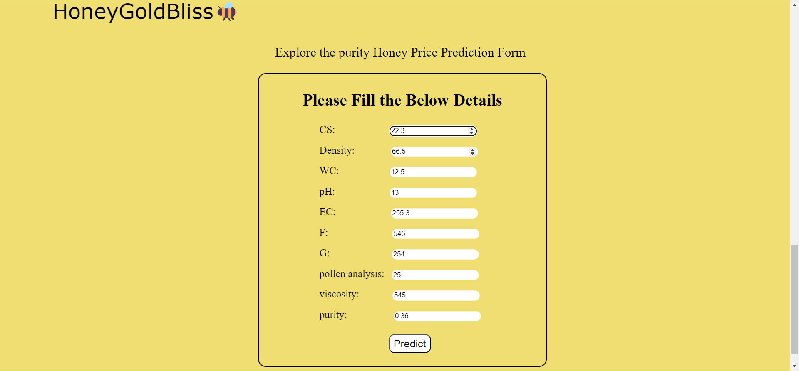

**Predict page**

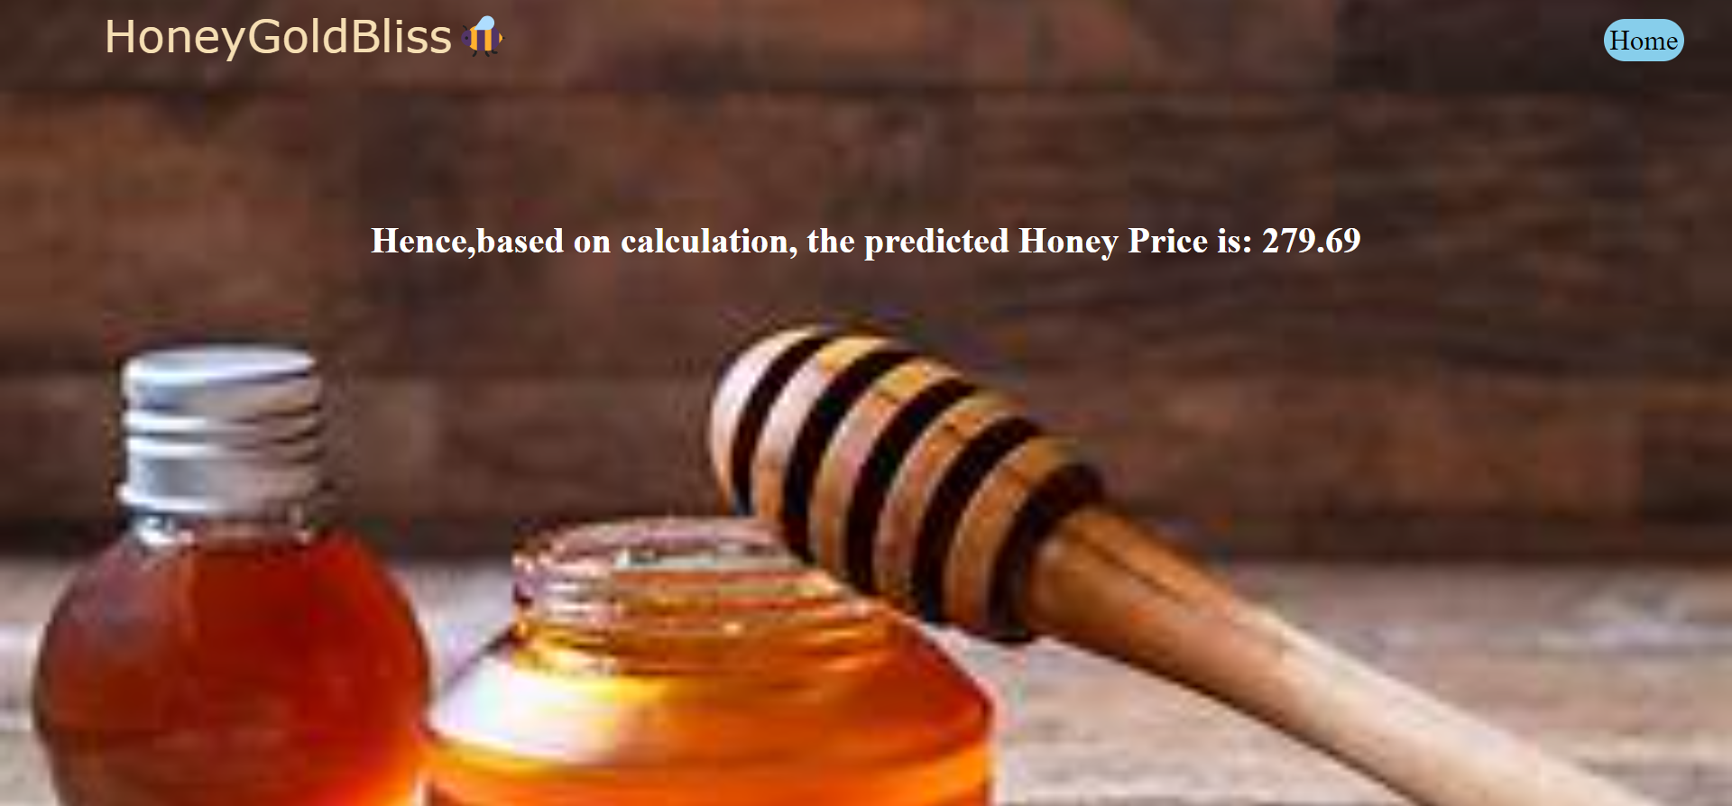

**7.Advantages & Disadvantages**

**ADVANTAGES:**

1. **Market Demand**: Consumers often prefer pure honey due to its perceived health benefits and superior taste. As awareness of adulteration grows, the demand for pure honey may increase, influencing prices.
2. **Supply Chain Transparency**: Brands and suppliers that can guarantee the purity of their honey may command higher prices due to consumer trust and perceived quality.
3. **Quality Standards and Certifications**: Honey certified by reputable organizations for purity (e.g., USDA Organic, European Union Organic) typically fetches higher prices in the Market
4. **Consumer Trends**: Trends in health and wellness, as well as environmental consciousness, can influence consumer preferences for pure honey, thereby impacting prices.

**DISADVANTAGES:**

1. **Complexity of Purity Assessment**: Determining the purity of honey can be

challenging and subjective. Various methods exist to assess purity, such as

laboratory testing for contaminants or adulterants (like added sugars), but

these methods can be costly and time-consuming.

1. **Variability in Purity Standards**: Purity standards may vary across regions and countries, making it difficult to establish consistent benchmarks for comparison. This variability can lead to discrepancies in how purity is defined and assessed in different markets.
2. **Market Manipulation**: Honey prices can be influenced by market speculation, supply chain dynamics, and geopolitical factors. Predicting these influences accurately, especially in volatile markets, can be challenging.

19

19

1. **Economic and Environmental Factors**: Factors such as weather conditions, bee health, and agricultural practices can affect honey production and purity. These external factors add uncertainty to price predictions based on purity alone.
2. **Technological Limitations**:Advanced technology is often required to detect sophisticated adulteration methods, which might not be accessible to all producers or regulatory bodies.Small-scale or local producers may lack the resources to employ high-end testing techniques.
3. **Environmental Impact:**Increased demand for pure honey can lead to intensive beekeeping practices that may not be sustainable.This can have negative impacts on bee populations and biodiversity.
4. **Cultural Differences:**Different cultures may have varying perceptions and traditional uses of honey, complicating the establishment of universal purity standards.What is considered "pure" in one culture might not be the same in another.

**8.Conclusion**

In this project, we aimed to predict the price of honey based on its purity. To achieve this, we utilized Python to analyze the data and employed three machine learning models: Random Forest, Decision Tree, and Linear Regression.

**Methodology and Data**

We started by collecting data on honey prices and their corresponding purity levels, which was stored in a CSV file. The dataset was then preprocessed to handle any missing values and to ensure it was suitable for analysis. We used two HTML files for data visualization and interaction, providing an intuitive interface for exploring the data and model predictions.

**Model Implementation**

Three different machine learning models were implemented to predict honey prices:

1. **Random Forest**: This ensemble learning method was used for its robustness and ability to handle complex data relationships.
2. **Decision Tree**: This model was chosen for its simplicity and interpretability, making it easy to understand how purity levels impact honey prices.
3. **Linear Regression**: As a fundamental regression technique, this model provided a baseline for understanding the linear relationship between purity and price.

🙾 Our analysis revealed that purity is a significant factor influencing honey prices. Among the three models, the Random Forest model demonstrated the highest accuracy, effectively capturing the non-linear relationships in the data. The Decision Tree model also performed well, providing clear insights into how different purity levels affect pricing. The Linear Regression model, while less accurate, confirmed a positive correlation between purity and price.

**9.Future Scope**

Future Scope of the Honey price Prediction and Management System:

1. **Expansion of Data Sources**: Expand data collection methods to include advanced analytical techniques and blockchain technology to enhance transparency in the honey supply chain.
2. **Integration of Machine Learning**: Further integrate machine learning algorithms to improve the accuracy of purity assessment and price prediction models, adapting to evolving market dynamics and consumer preferences.
3. **Global Market Analysis**: Extend predictive models to encompass global honey markets, considering regional variations in production, consumption patterns, and regulatory environments affecting purity standards.
4. **Forecasting Tools for Industry Planning**: Develop forecasting tools tailored for honey producers and distributors to optimize production, inventory management, and pricing strategies based on anticipated shifts in market demand for pure honey.

**10.Appendix**

**10.1 Source Code**

**Index Page:**

<!DOCTYPE html>

<html>

<head>

<title>HoneyGoldBliss</title>

<link rel="stylesheet" href="{{ url_for('static', filename='assets/css/index.css') }}">

<meta name="viewport" content="width=device-width,initial-scale=1.0">

</head>

<body>

<div id="lg">

<div id="ns">

<header id="name">HoneyGoldBliss&#128029;</header>

<nav id="nav">

<ul>

<li><a href="#" class="active">Home</a></li>

<li><a href="#about">About</a></li>

<li><a href="#">Why us?</a></li>

<li><a href="#">Contact</a></li>

<li><a href="#predict" id="pr">Predict</a></li>

</ul>

</nav>

</div>

<div id="tq">

<h1 id="title">HoneyMetrics:Predicting Purity and Price</h1>

<p id="quo">"In every drop of pure honey,lies the essence of dilignet bees and the purest essence of flowers"</p>

</div>

</div>

<!--about-->

<div id="about">

<nav id="nava">

<ul>

<li><a href="#lg" class="active">Home</a></li>

<li><a href="#predict" id="pr">Predict</a></li>

</ul>

</nav>

<div id="ac">

<aside id="au">About us &#127855;&#128029; :</aside>

<main id="cont">

<p>At HoneyMetrics,we are dedicated to revolutionizing the honey industry by providing cutting-edge solutions for predicting purity and price.with our innovative technology and data-driven approach,we empower consumers,producers,and distributors to make informed decisions about honey quality and market value.

<br><br>our platform utilizes advanced algorithms and machine learning models to analyze various factors influencing honey purity,including floral sources,geographical origin,processing methods,and more.By harnessing the power of big data,we deliver accurate predictions that ensure transparency and trust in the honey supply chain.

<br><br>whether you're a consumer seeking high-quality honey products or beekeeper looking to optimize production and pricing strategies,HoneyMetrics is your go-to resource for reliable insights and actionable intelligence.join us in shaping the future of the honey industry and promoting integrity throughout the entrie value chain.

</p>

</main>

</div>

</div>

<!--predict-->

<div id="predict">

<header id="namep">HoneyGoldBliss&#128029;</header>

<p id="qu">Explore the purity Honey Price Prediction Form</p>

<div id="formbox">

<h1><b>Please Fill the Below Details</b></h1>

<form action="/inner_page" method="POST">

<label for="cs">CS:</label>

<input type="number" id="cs" name="cs" step="0.01" required>

<br>

<label for="D">Density:</label>

<input type="number" id="D" name="D" step="0.01" required>

<br>

<label for="W">WC:</label>

<input type="number" id="w" name="w" step="0.01" required>

<br>

<label for="P">pH:</label>

<input type="number" id="P" name="p" step="0.01" required>

<br>

<label for="E">EC:</label>

<input type="number" id="E" name="E" step="0.01" required>

<br>

<label for="f">F:</label>

<input type="number" id="f" name="f" step="0.01" required>

<br>

<label for="g">G:</label>

<input type="number" id="g" name="g" step="0.01" required>

<br> 26

<label for="po">pollen analysis:</label>

<input type="number" id="po" name="po" step="0.01" required>

<br>

<label for="vis">viscosity:</label>

<input type="number" id="vis" name="vis" step="0.01" required>

<br>

<label for="pu">purity:</label>

<input type="number" id="pu" name="pu" step="0.01" required>

<br>

<button id="bu">Predict</button>

</form>

</div>

</div>

</body>

</html>

**INDEX.CSS**

body{

box-sizing: border-box;

margin: 0;

padding: 0;

background-image: url(img.jpg);

background-size: 100% 800px;

object-fit: contain;

background-repeat: no-repeat;

}

#lg{

background: linear-gradient(to bottom right,rgba(96, 92, 92, 0.5),rgba(168,168,168,0.5));

width: 100%;

height: 750px;

}

#ns{

position: sticky;

}

#name{

font-size: 40px;

margin: 0 5%;

padding: 15px;

font-family: Verdana, Geneva, Tahoma, sans-serif;

color: wheat;

position: static;

}

#nav ul{

list-style-type: none;

display: flex;

justify-content: flex-end;

gap: 10px;

margin:-55px 100px;

position: sticky;

}

#nav li a{

text-decoration: none;

font-size: 25px;

color: black;

padding: 10px;

}

#nav li a.active{

color:gold;

}

#pr{

background-color: skyblue;

padding: 2px;

border-radius: 25px;

}

@media screen and (min-width:0) and (max-width:768px) {

#nav ul{

width: auto;

height: auto;

overflow: hidden;

position: relative;

margin-top:25px;

display: block;

}

#nav li{

float:left;

}

#nav li a{

padding:10px;

}

}

#tq{

margin: 0;

padding: 2px;

text-align: center;

}

#title{

font-size: 45px;

font-family:Arial, Helvetica, sans-serif;

margin-top: 200px;

color: white;

}

#quo{

font-size: 18px;

font-family:sans-serif;

font-style: italic;

margin-top: -15px;

color: whitesmoke;

}

/ABout/

#about{

width: 100%;

height: 750px;

padding: 10px;

background-color: blanchedalmond;

}

#nava ul{

list-style-type: none;

display: flex;

justify-content: flex-end;

gap: 10px;

margin:50px 100px;

position: sticky;

}

#nava li a{

text-decoration: none;

font-size: 25px;

color: black;

padding: 10px;

}

#nava li a.active{

color:gold;

}

#ac{

display: flex;

margin-left: 70px;

margin-top: 10%;

}

#au{

font-size: 40px;

margin-left: 8%;

margin-top: -50px;

font-family: 'Segoe UI', Tahoma, Geneva, Verdana, sans-serif;

}

#cont{

width: 50%;

height: auto;

padding: 10px;

font-size: 20px;

margin-left: 5%;

font-family:'Times New Roman', Times, serif;

}

/predict/

#predict{

width: 100%;

height: 780px;

padding: 10px;

background-color:rgb(240, 222, 115);

}

#namep{

font-size: 40px;

margin: 0 5%;

padding: 15px;

font-family: Verdana, Geneva, Tahoma, sans-serif;

color: black;

}

#qu{

text-align: center;

font-size: 25px;

}

#formbox{

width:35%;

height: auto;

border: 2px solid black;

border-radius: 15px;

margin-left: 32%;

padding: 10px;

}

#formbox h1{

text-align: center;

}

#formbox label{

font-size: 20px;

margin-left: 20%;

}

#formbox input[type=number]{

border: 1px solid beige;

border-radius: 10px;

margin: 10px ;

}

#formbox input[type=number]#cs{

margin-left: 95px ;

}

#formbox input[type=number]#D{

margin-left:60px ;

}#formbox input[type=number]#w{

margin-left: 90px ;

}#formbox input[type=number]#P{

margin-left: 100px ;

}#formbox input[type=number]#E{

margin-left: 100px ;

}#formbox input[type=number]#f{

margin-left: 115px ;

}#formbox input[type=number]#g{

margin-left: 115px ;

}#formbox input[type=number]#vis{

margin-left: 60px ;

}

#formbox input[type=number]#pu{

margin-left: 80px ;

}

#bu{

cursor: pointer;

margin: 15px 45%;

font-size: 20px;

background-color: white;

color:black;

padding: 5px 8px;

border-radius: 12px;

}

**PREDICT.HTML**

<!DOCTYPE html>

<html>

<head>

<title>HoneyGoldBliss Prediction</title>

<link rel="stylesheet" href="{{ url_for('static', filename='assets/css/inner_page.css') }}">

</head>

<body>

<header id="name">HoneyGoldBliss&#128029;</header>

<h1 id="output">{{ prediction_text }}</h1>

</body>

**PREDICT.CSS**

body{

box-sizing: border-box;

padding: 0;

margin: 0;

background-image: url("../img/img2.jpeg");

background-size: 100% 400%;

background-repeat: no-repeat;

object-fit: contain;

}

#name{

font-size: 40px;

margin: 0 5%;

padding: 15px;

font-family: Verdana, Geneva, Tahoma, sans-serif;

color: wheat;

position: static;

}

ul{

list-style-type: none;

margin:-50px 90% -10px ;

}

li a{

text-decoration: none;

font-size: 25px;

color: black;

padding: 10px;

}

#ho{

background-color: skyblue;

padding: 5px;

border-radius: 25px;

}

#output{

text-align: center;

color: white;

margin-top:10%;

}

**APP.PY**

import pickle

import pandas as pd

import os

from flask import Flask,request,render_template

app=Flask(_name_)

model = pickle.load(open('RaRmodel.pkl','rb'))

@app.route('/')

def home():

return render_template('index.html')

@app.route('/inner_page',methods=["POST","GET"])

def predict():

input_features = [float(x) for x in request.form.values()]

features_values = [np.array(input_features) ]

print(features_values)

names=['cs','D','w','p','E','f','g','po','Vis','pu']

df = pd.DataFrame(features_values, columns= names)

prediction = model.predict(df)

print(prediction[0])

rounded_value = round(prediction[0], 2)

text="Hence,based on calculation, the predicted Honey Price is: "

return render_template('inner_page.html', prediction_text=text + str(rounded_value))

if _name_ == '_main_':

app.run(debug = False, port=5000)

**Code snippetes**

**Data collection**

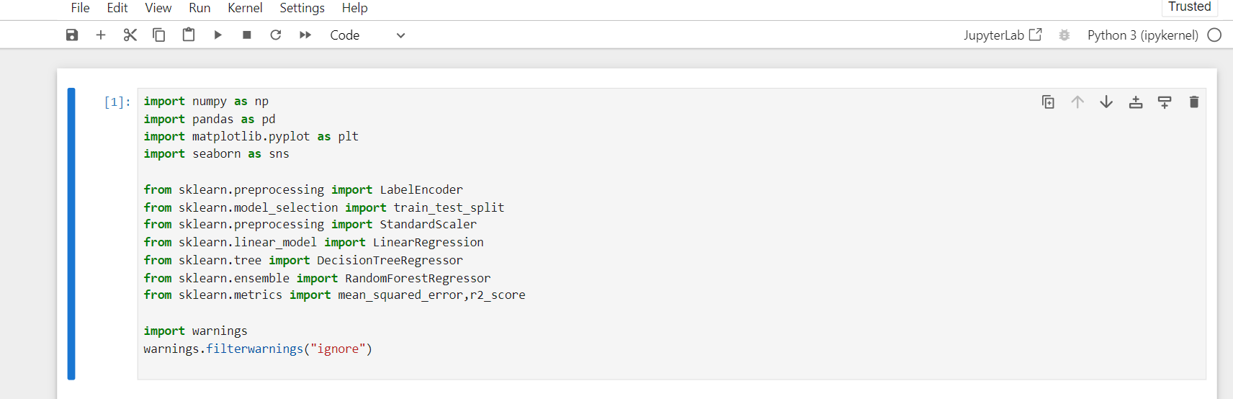

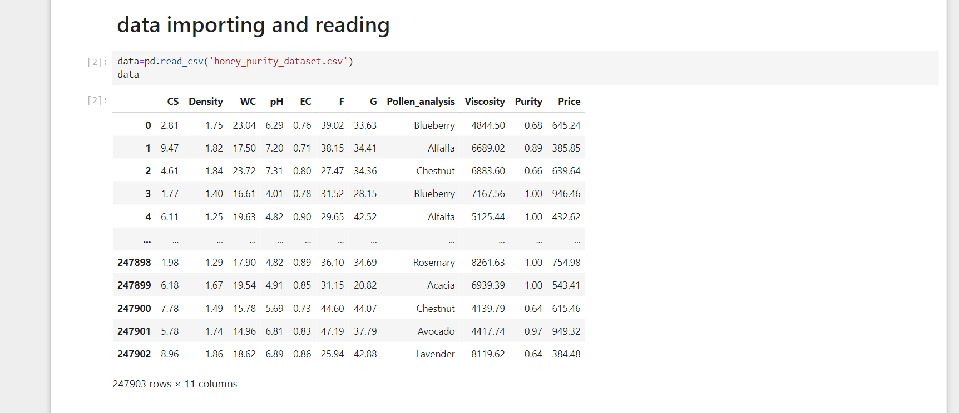

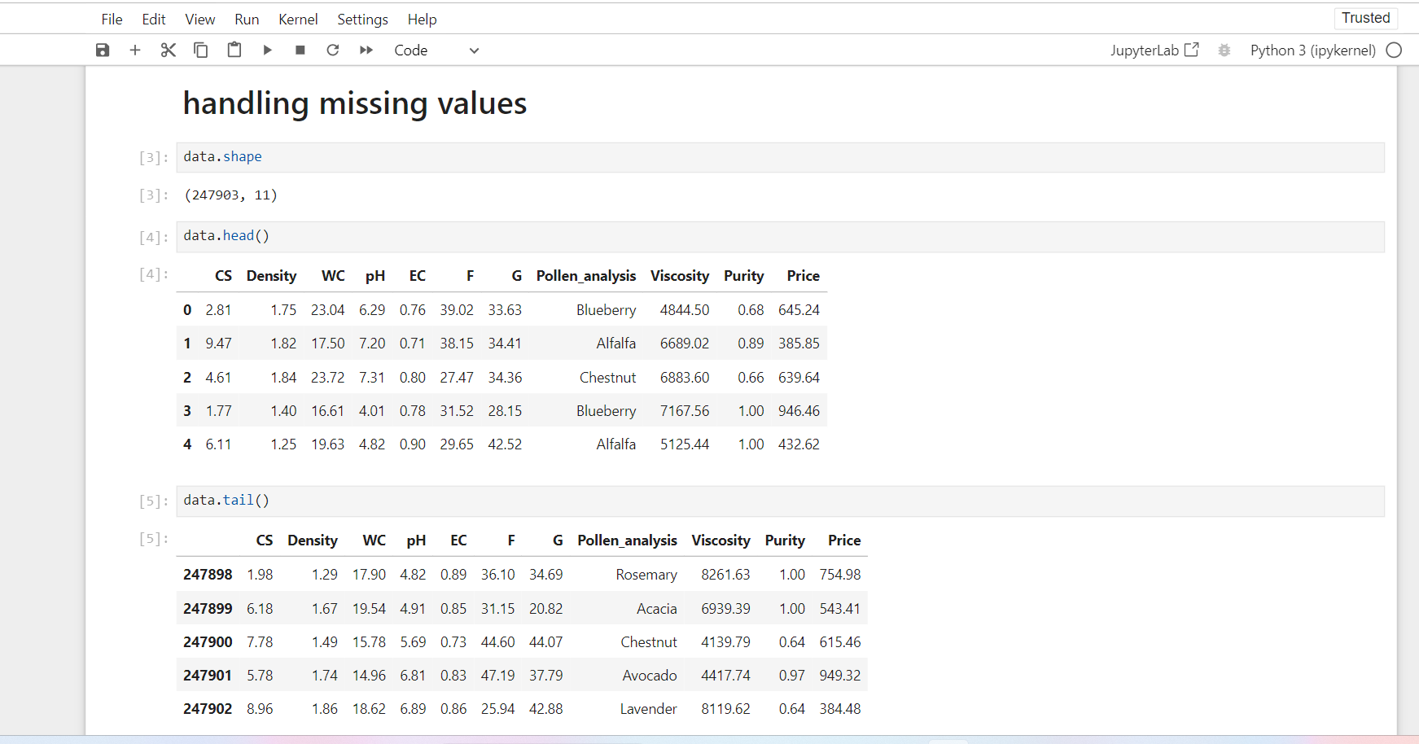

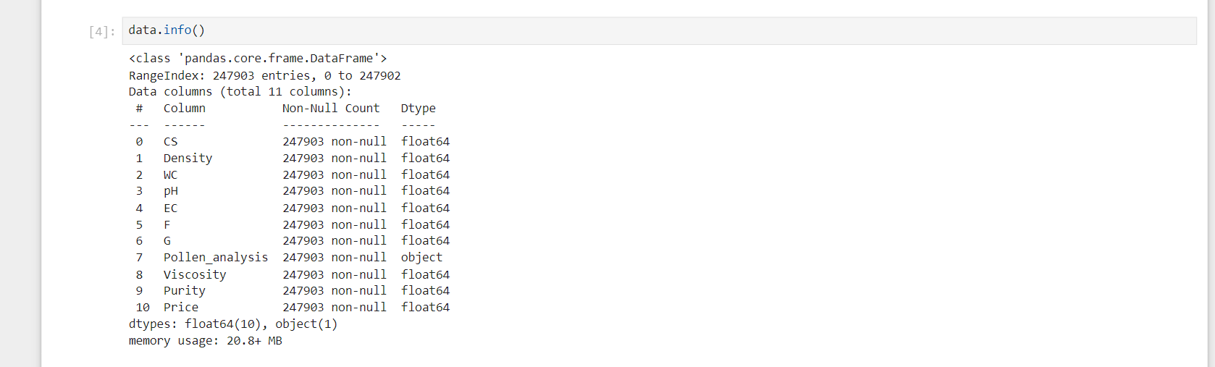

**Handling categorical values**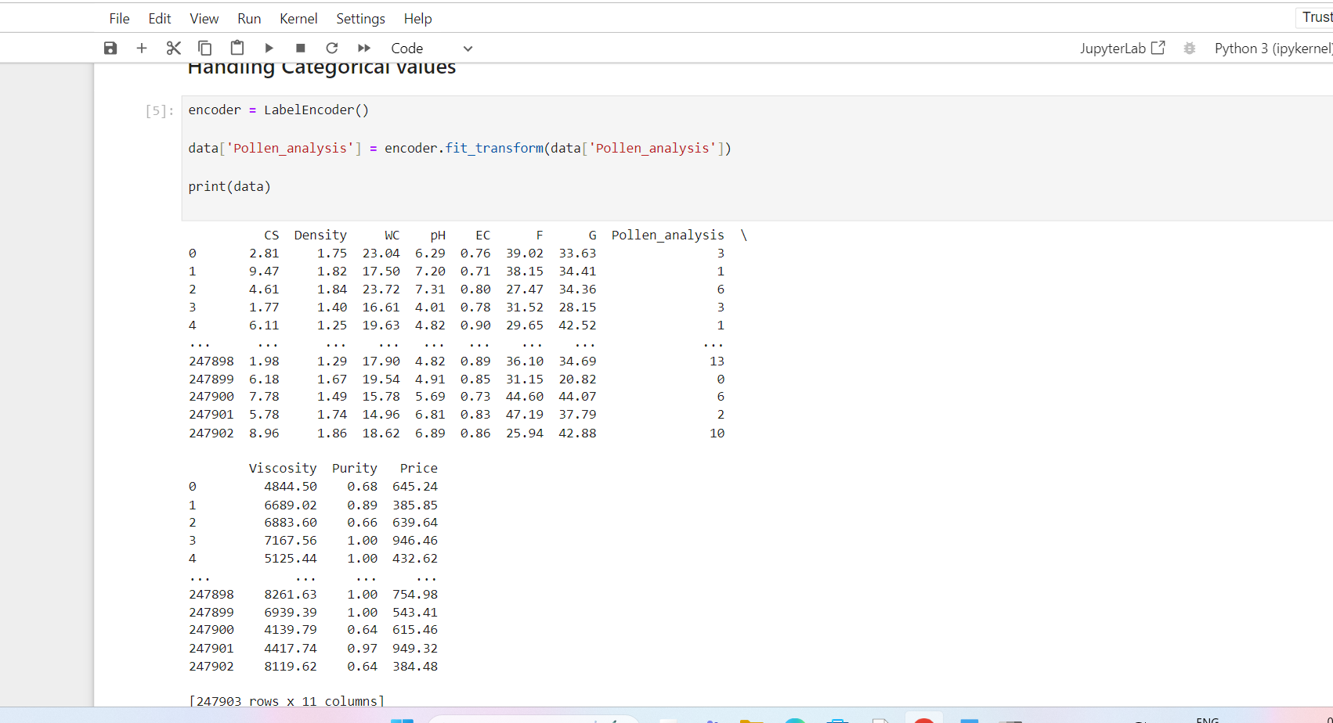

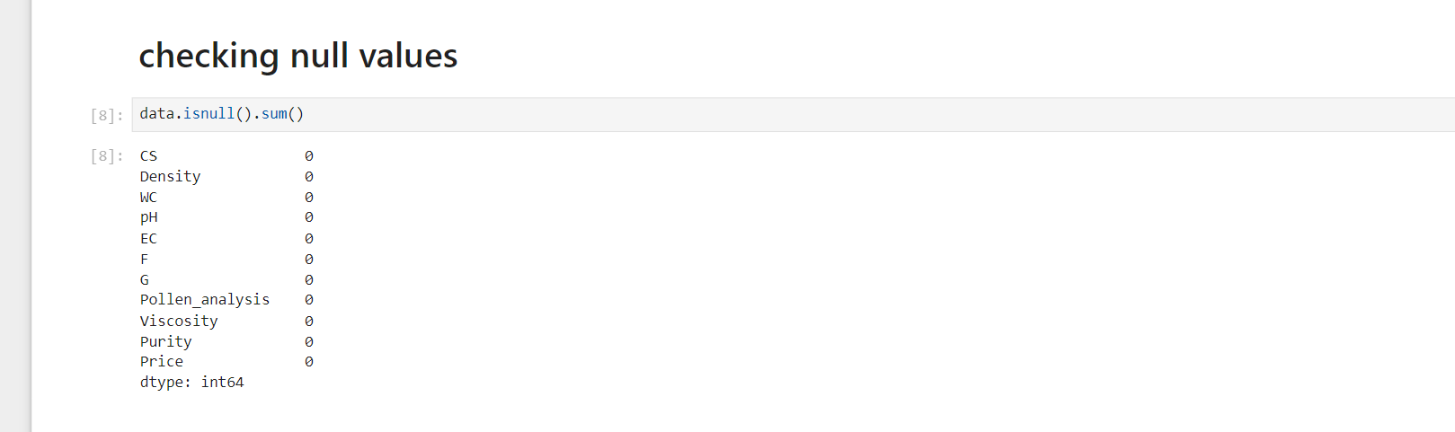

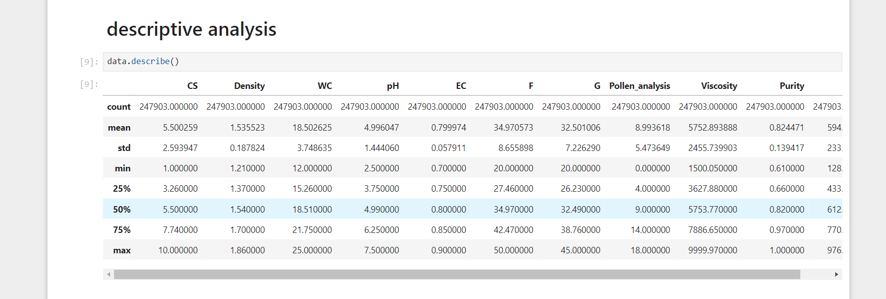

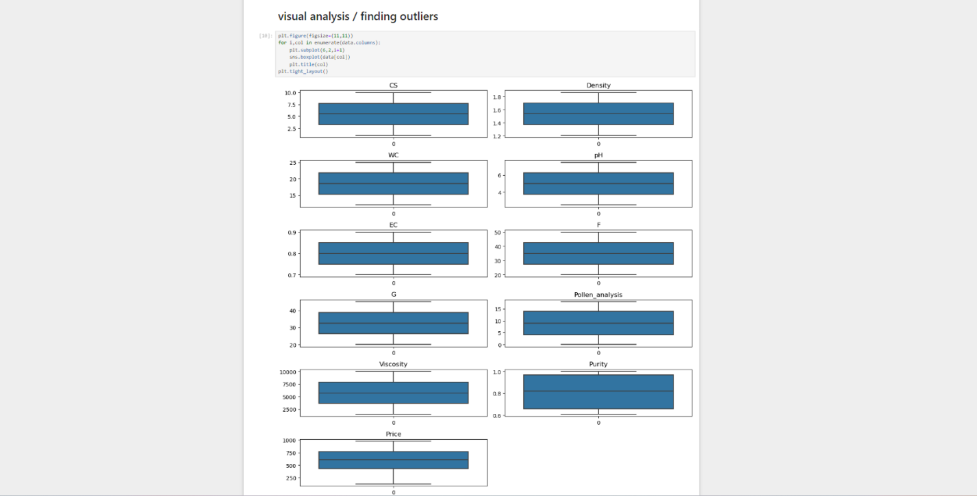

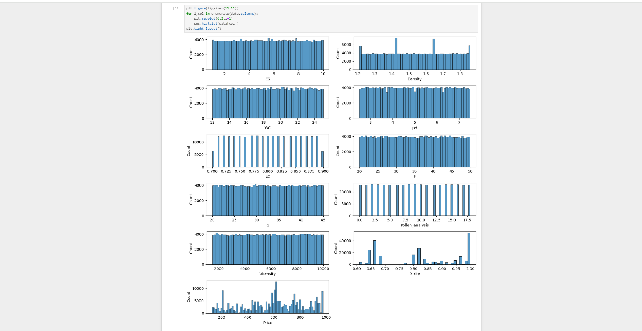

**Univariayte analysis:**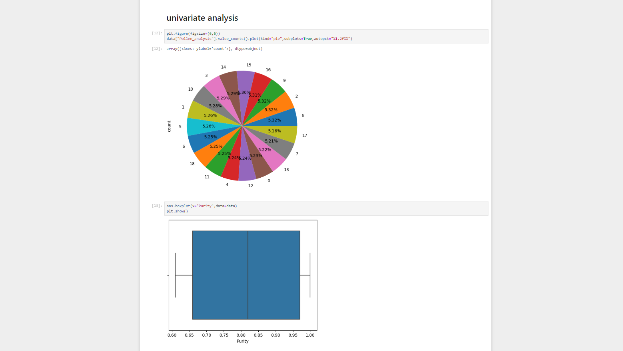

**Bivariate analysis:**

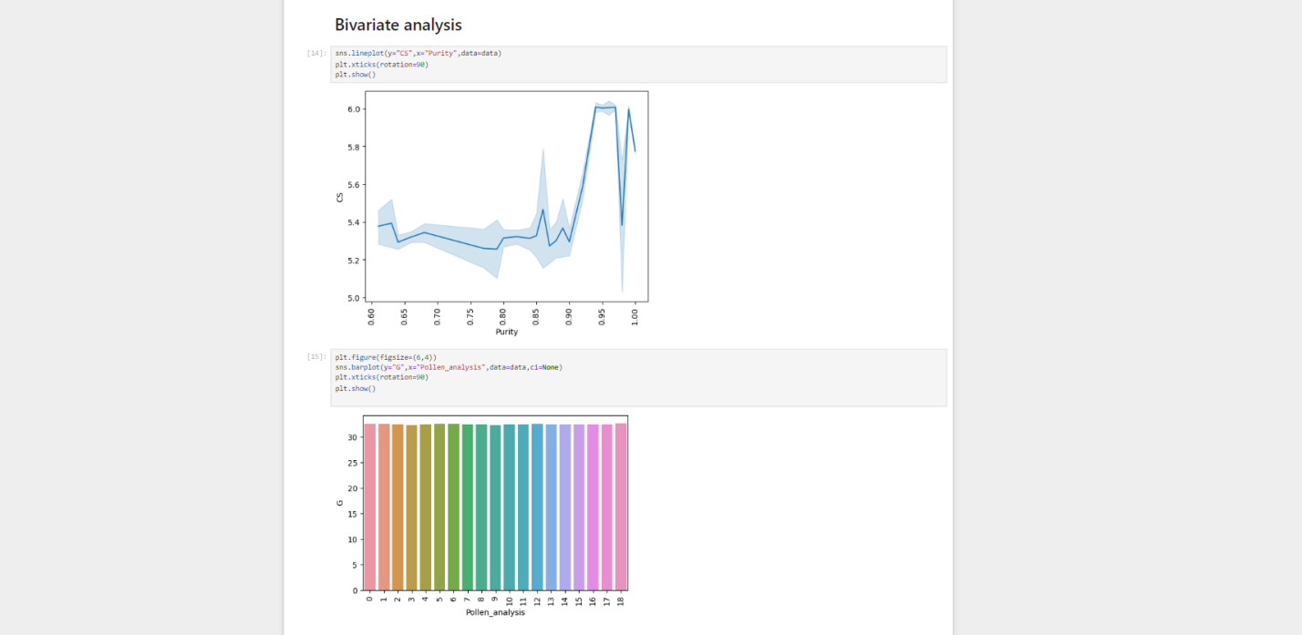

**Multivariate analysis:**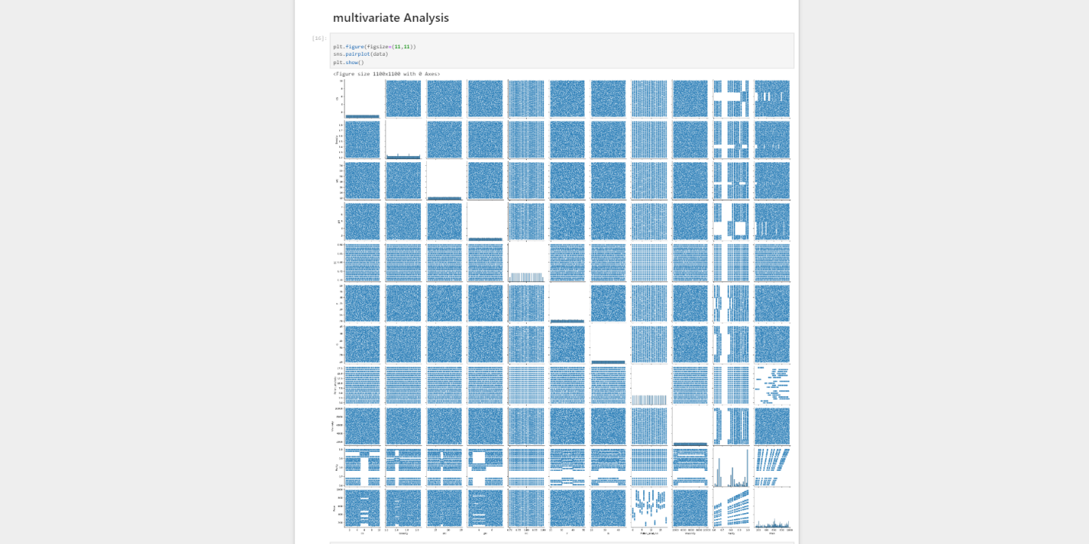

**Model Building:**

